

1. **Test Cases:**

|  |  |  |  |  |  |
| --- | --- | --- | --- | --- | --- |
| Project Name: Government Regulated Price Hike Control Application. | | | Test Designed by: MD. MEHEDI HASAN POLASH | | |
| Test Case ID: GRPHCA_01 | | | Test Designed date: 9/9/2024 | | |
| Test Priority (Low, Medium, High): High | | | Test Executed by: MD. MEHEDI HASAN POLASH | | |
| Module Name: Registration | | | Test Execution date: 9/9/2024 | | |
| Test Title: Register with username, email address, contact number, NID number, company name, address, user type, birth date, gender, password, confirm password, payment. | | | | | |
| Description: This test validates the registration process on the software's signup page. | | | | | |
| Precondition (If any): The user is required to submit all necessary information, ensuring uniqueness and proper validation. | | | | | |
| Test Steps | Test Data | Expected Results | | Actual Results | Status |
| 1. Launch the software 2. Provide details for each section 3. Check all the required section   4. Enter signup button | Username: polash  Email: polash@gmail.com  Password: #55Srb  Confirm Password: #55Srb  Contact number: +88 01452369752  NID number: ******  Company name: ***  Address: ****  User type: Reseller or Producer or Wholesaler  Birth date: ***  Gender: Male or Female  Payment: **** | The user should successfully complete the registration process, and all submitted information must be stored in the database for future validation. | | As expected, | Pass |
| Post Condition: All data is saved in the database for future validation. | | | | | |

|  |  |  |  |  |  |
| --- | --- | --- | --- | --- | --- |
| Project Name: Government Regulated Price Hike Control Application. | | | Test Designed by: MD. MEHEDI HASAN POLASH | | |
| Test Case ID: GRPHCA_02 | | | Test Designed date: 9/9/2024 | | |
| Test Priority (Low, Medium, High): High | | | Test Executed by: MD. MEHEDI HASAN POLASH | | |
| Module Name: Registration | | | Test Execution date: 9/9/2024 | | |
| Test Title: Register with username, email address, contact number, NID number, company name, address, user type, birth date, gender, password, confirm password, payment. | | | | | |
| Description: This test validates the registration process on the software's signup page. | | | | | |
| Precondition (If any): The user is required to submit all necessary information, ensuring uniqueness and proper validation. | | | | | |
| Test Steps | Test Data | Expected Results | | Actual Results | Status |
| 1. Launch the software 2. Provide details for each section 3. Check all the required section   4. Enter signup button | Username: polash  Email: polash@gmail.com  Password: #55Srb  Confirm Password: #55Srb  Contact number: +88 014552  NID number: ******  Company name: ***  Address: ****  User type: Reseller or Producer or Wholesaler  Birth date: ***  Gender: Male or Female  Payment: **** | The user should successfully complete the registration process, and all submitted information must be stored in the database for future validation. | | Not as expected (Contact number invalid) | Fail |
| Post Condition: The user is not registered, remains on the registration page, and is prompted with an error message to correct the invalid contact number. The dashboard is not accessible until the issue is resolved and registration is completed successfully. | | | | | |

|  |  |  |  |  |  |  |
| --- | --- | --- | --- | --- | --- | --- |
| Project Name: Government Regulated Price Hike Control Application. | | | | Test Designed by: TRIDIB SARKAR | | |
| Test Case ID: | GRPHCA_03 |  |  | Test Designed date: 9/9/2024 | | |
| Test Priority (Low, Medium, High): High | | | | Test Executed by: TRIDIB SARKAR | | |
| Module Name: Login | | | | Test Execution date: 9/9/2024 | | |
| Test Title: Login with user type, user id and password | | | | | | |
| Description: This test checks that the software's login functionality works correctly with valid credentials. | | | | | | |
| Precondition (If any): To access this, users need to be registered and have valid login credentials. | | | | | | |
| Test Steps | | Test Data | Expected Results | | Actual Results | Status (Pass/Fail) |
| 1. Open the software 2. Select login/signup 3. Select user type 4. Enter user id 5. Enter password | | User type: Reseller or Producer or Wholesaler  User id: 753159  Password: 45dwta$ | The user should log in successfully and gain access to the dashboard. | | As expected, | Pass |
|  | |  | |  |  |
|  | |  | |  |  |
| Post Condition: The user is logged in and has successfully accessed the dashboard. | | | | | | |

|  |  |  |  |  |  |  |
| --- | --- | --- | --- | --- | --- | --- |
| Project Name: Government Regulated Price Hike Control Application. | | | | Test Designed by: TRIDIB SARKAR | | |
| Test Case ID: | GRPHCA_04 |  |  | Test Designed date: 9/9/2024 | | |
| Test Priority (Low, Medium, High): High | | | | Test Executed by: TRIDIB SARKAR | | |
| Module Name: Login | | | | Test Execution date: 9/9/2024 | | |
| Test Title: Login with user type, user id and password | | | | | | |
| Description: This test validates the software's login functionality with correct credentials | | | | | | |
| Precondition (If any): The user must be registered and possess valid login credentials | | | | | | |
| Test Steps | | Test Data | Expected Results | | Actual Results | Status (Pass/Fail) |
| 1. Open the software 2. Select login/signup 3. Select user type 4. Enter user id 5. Enter password | | User type: Reseller or Producer or Wholesaler  User id: 75159  Password: 45wta$ | The user should log in successfully and gain access to the dashboard. | | Not as expected (invalid user id or password) | Fail |
|  | |  | |  |  |
|  | |  | |  |  |
| Post Condition: The user is not logged in successfully in the dashboard because of invalid user id or password. | | | | | | |

|  |  |  |  |  |  |  |
| --- | --- | --- | --- | --- | --- | --- |
| Project Name: Government Regulated Price Hike Control Application. | | | | Test Designed by: MD. YASIR ARAFAT TAMIM | | |
| Test Case ID: | GRPHCA_05 |  |  | Test Designed date: 9/9/2024 | | |
| Test Priority (Low, Medium, High): High | | | | Test Executed by: MD. YASIR ARAFAT TAMIM | | |
| Module Name: Forgot password | | | | Test Execution date: 10/9/2024 | | |
| Test Title: Password reset | | | | | | |
| Description: Test software forgot password page | | | | | | |
| Precondition (If any): User must fill-up all the requirements with uniqueness and validation | | | | | | |
| Test Steps | | Test Data | Expected Results | | Actual Results | Status (Pass/Fail) |
| 1. Open the software     2. Click forgot password  3. Enter mail address   1. Enter code form mail 2. Click Continue 3. Enter new password 4. Reenter new password   8. Click update password | | Email:  tamim@gmail.com  Enter code: 1234  Password: @1259t  Confirm Password:  @1259t | User should be able  to reset password. | | As expected, | Pass |
|  | |  | |  |  |
|  | |  | |  |  |
| Post Condition: All information is recorded in the database for future verification. | | | | | | |

|  |  |  |  |  |  |  |
| --- | --- | --- | --- | --- | --- | --- |
| Project Name: Government Regulated Price Hike Control Application. | | | Test Designed by: CHAYAN ADHIKARY | | | |
| Test Case ID: | GRPHCA_06 |  | Test Designed date: 09/11/2024 | | | |
| Test Priority (Low, Medium, High): High | | | Test Executed by: CHAYAN ADHIKARY | | | |
| Module Name: New Product Entry | | | Test Execution date: 09/11/2024 | | | |
| Test Title: Test the functionality of New Product Add | | | | | | |
| Description: This test verifies the functionality of the new product add with product ID, price, stock, entry date etc. | | | | | | |
| Precondition (If any): User must be logged in to their own Dashboard. | | | | | | |
| Test Steps | | Test Data | | Expected Results | Actual Results | Status (Pass/Fail) |
| Test Steps: | | Shown on the side table:  GR2232  Sugar  60 tk/kg  Grocery  TCB  100000 ton  9/11/2024 | | Product info should be entered on the side table and home page. | As expected, | Pass |
| 1. Log in to the Reseller Dashboard. | |  |  |
| 1. Enter Product ID: GR2232 | |  |  |
| 1. Enter Product Name: Sugar | |  |  |
| 1. Enter Product Price: 60 tk/kg | |  |  |
| 1. Enter Category: Grocery | |  |  |
| 1. Enter Brand Name: TCB 2. Enter Current Stock: 100000 ton 3. Click Add button | |  |  |
| 9. Confirm smooth product entry. | |  |  |
|  | |  |  |
| Post Condition: The user successfully added product information to the information table which will be shown on the side and also in the home page. Product entry date will be shown automatically. | | | | | | |

|  |  |  |  |  |  |  |
| --- | --- | --- | --- | --- | --- | --- |
| Project Name: Government Regulated Price Hike Control Application. | | | Test Designed by: CHAYAN ADHIKARY | | | |
| Test Case ID: | GRPHCA_07 |  | Test Designed date: 09/11/2024 | | | |
| Test Priority (Low, Medium, High): High | | | Test Executed by: CHAYAN ADHIKARY | | | |
| Module Name: New Product Entry | | | Test Execution date: 09/11/2024 | | | |
| Test Title: Test the functionality of New Product Add | | | | | | |
| Description: This test verifies the functionality of the New Product Add with product ID, price, stock, entry date etc. If there is any missing information, the product should not be listed in the table. | | | | | | |
| Precondition (If any): User must be logged in to their own Dashboard. | | | | | | |
| Test Steps | | Test Data | | Expected Results | Actual Results | Status (Pass/Fail) |
| Test Steps: | | Error Message: Fill all blanks | | Product info shouldn't show in the table with an empty cell. Also, a pop-up error message should be shown. | As expected, | Pass |
| 1. Log in to the Reseller Dashboard. | |  |  |
| 2. Enter Product ID: GR2232 | |  |  |
| 3. Enter Product Name: Sugar | |  |  |
| 1. Enter Product Price: Leave Empty 2. Enter Category: Grocery 3. Enter Brand Name: TCB 4. Enter Current Stock: 1037727 ton | |  |  |
| Post Condition: The user will not successfully add product information to the information table and a pop up shown. | | | | | | |

|  |  |  |  |  |  |  |
| --- | --- | --- | --- | --- | --- | --- |
| Project Name: Government Regulated Price Hike Control Application. | | | Test Designed by: PROGGA PAROMITA DAS | | | |
| Test Case ID: | GRPHCA_08 |  | Test Designed date: 09/11/2024 | | | |
| Test Priority (Low, Medium, High): High | | | Test Executed by: PROGGA PAROMITA DAS | | | |
| Module Name: Previous Product Update | | | Test Execution date: 10/11/2024 | | | |
| Test Title: Test the functionality of Previous Product Update | | | | | | |
| Description: This test verifies the functionality of the Previous Product Update with product ID, price, stock. Entry date will be automatically updated | | | | | | |
| Precondition (If any): User must be logged in to their own Dashboard. | | | | | | |
| Test Steps | | Test Data | | Expected Results | Actual Results | Status (Pass/Fail) |
| Test Steps: | | Shown on the side table:  GR2232 Sugar  65 tk/kg  Grocery  TCB  1000027 ton  10/11/2024 | | Product info updated in a new row with auto date update. | As expected, | Pass |
| 1. Log in to the Reseller Dashboard. | |  |  |
| 2. Enter Product ID: GR2232 | |  |  |
| 3. Enter Updated Price: 65 | |  |  |
| 4. Enter Updated Stock: 1000027 ton  5. Click Update button | |  |  |
| 6. Confirm smooth product update. | |  |  |
|  | |  |  |
|  | |  |  |
|  | |  |  |
| Post Condition: The user successfully see an update on the table. | | | | | | |

|  |  |  |  |  |  |  |
| --- | --- | --- | --- | --- | --- | --- |
| Project Name: Government Regulated Price Hike Control Application. | | | Test Designed by: PROGGA PAROMITA DAS | | | |
| Test Case ID: | GRPHCA_09 |  | Test Designed date: 09/11/2024 | | | |
| Test Priority (Low, Medium, High): High | | | Test Executed by: PROGGA PAROMITA DAS | | | |
| Module Name: Previous Product Update | | | Test Execution date: 10/11/2024 | | | |
| Test Title: Test the functionality of Previous Product Update | | | | | | |
| Description: This test verifies the functionality of the Previous Product Update with product ID, price, stock. Entry date will be automatically updated. In this test a product will be deleted totally. | | | | | | |
| Precondition (If any): User must be logged in to their own Dashboard. | | | | | | |
| Test Steps | | Test Data | | Expected Results | Actual Results | Status (Pass/Fail) |
| Test Steps: | | GR2232 Row will be deleted | | One row deletes | As expected, | Pass |
| 1. Log in to the Reseller Dashboard. | |  |  |
| 2. Enter Product ID: GR2232 | |  |  |
|  | |  |  |
| 2. Click Delete button | |  |  |
| 3. Confirm smooth product remove | |  |  |
|  | |  |  |
|  | |  |  |
|  | |  |  |
| Post Condition: The user will not see the sugar row in the data table. | | | | | | |

1. UI Design:





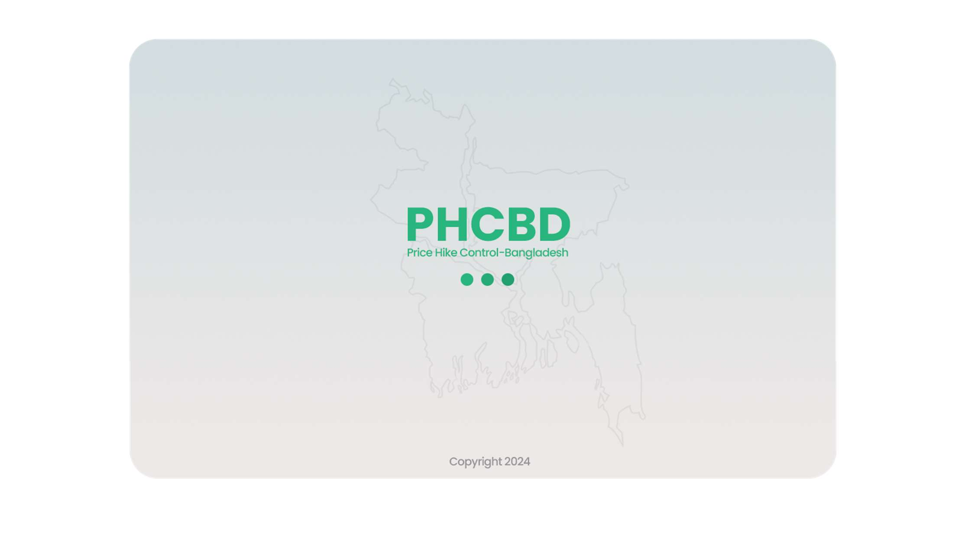

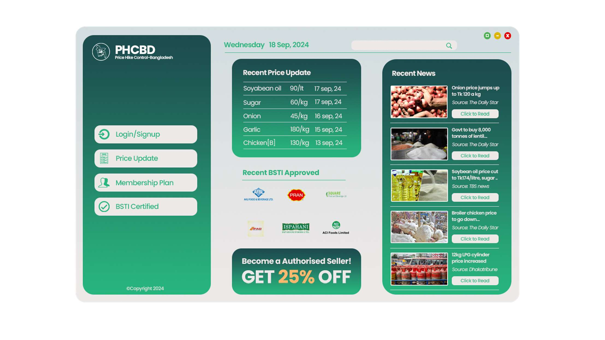

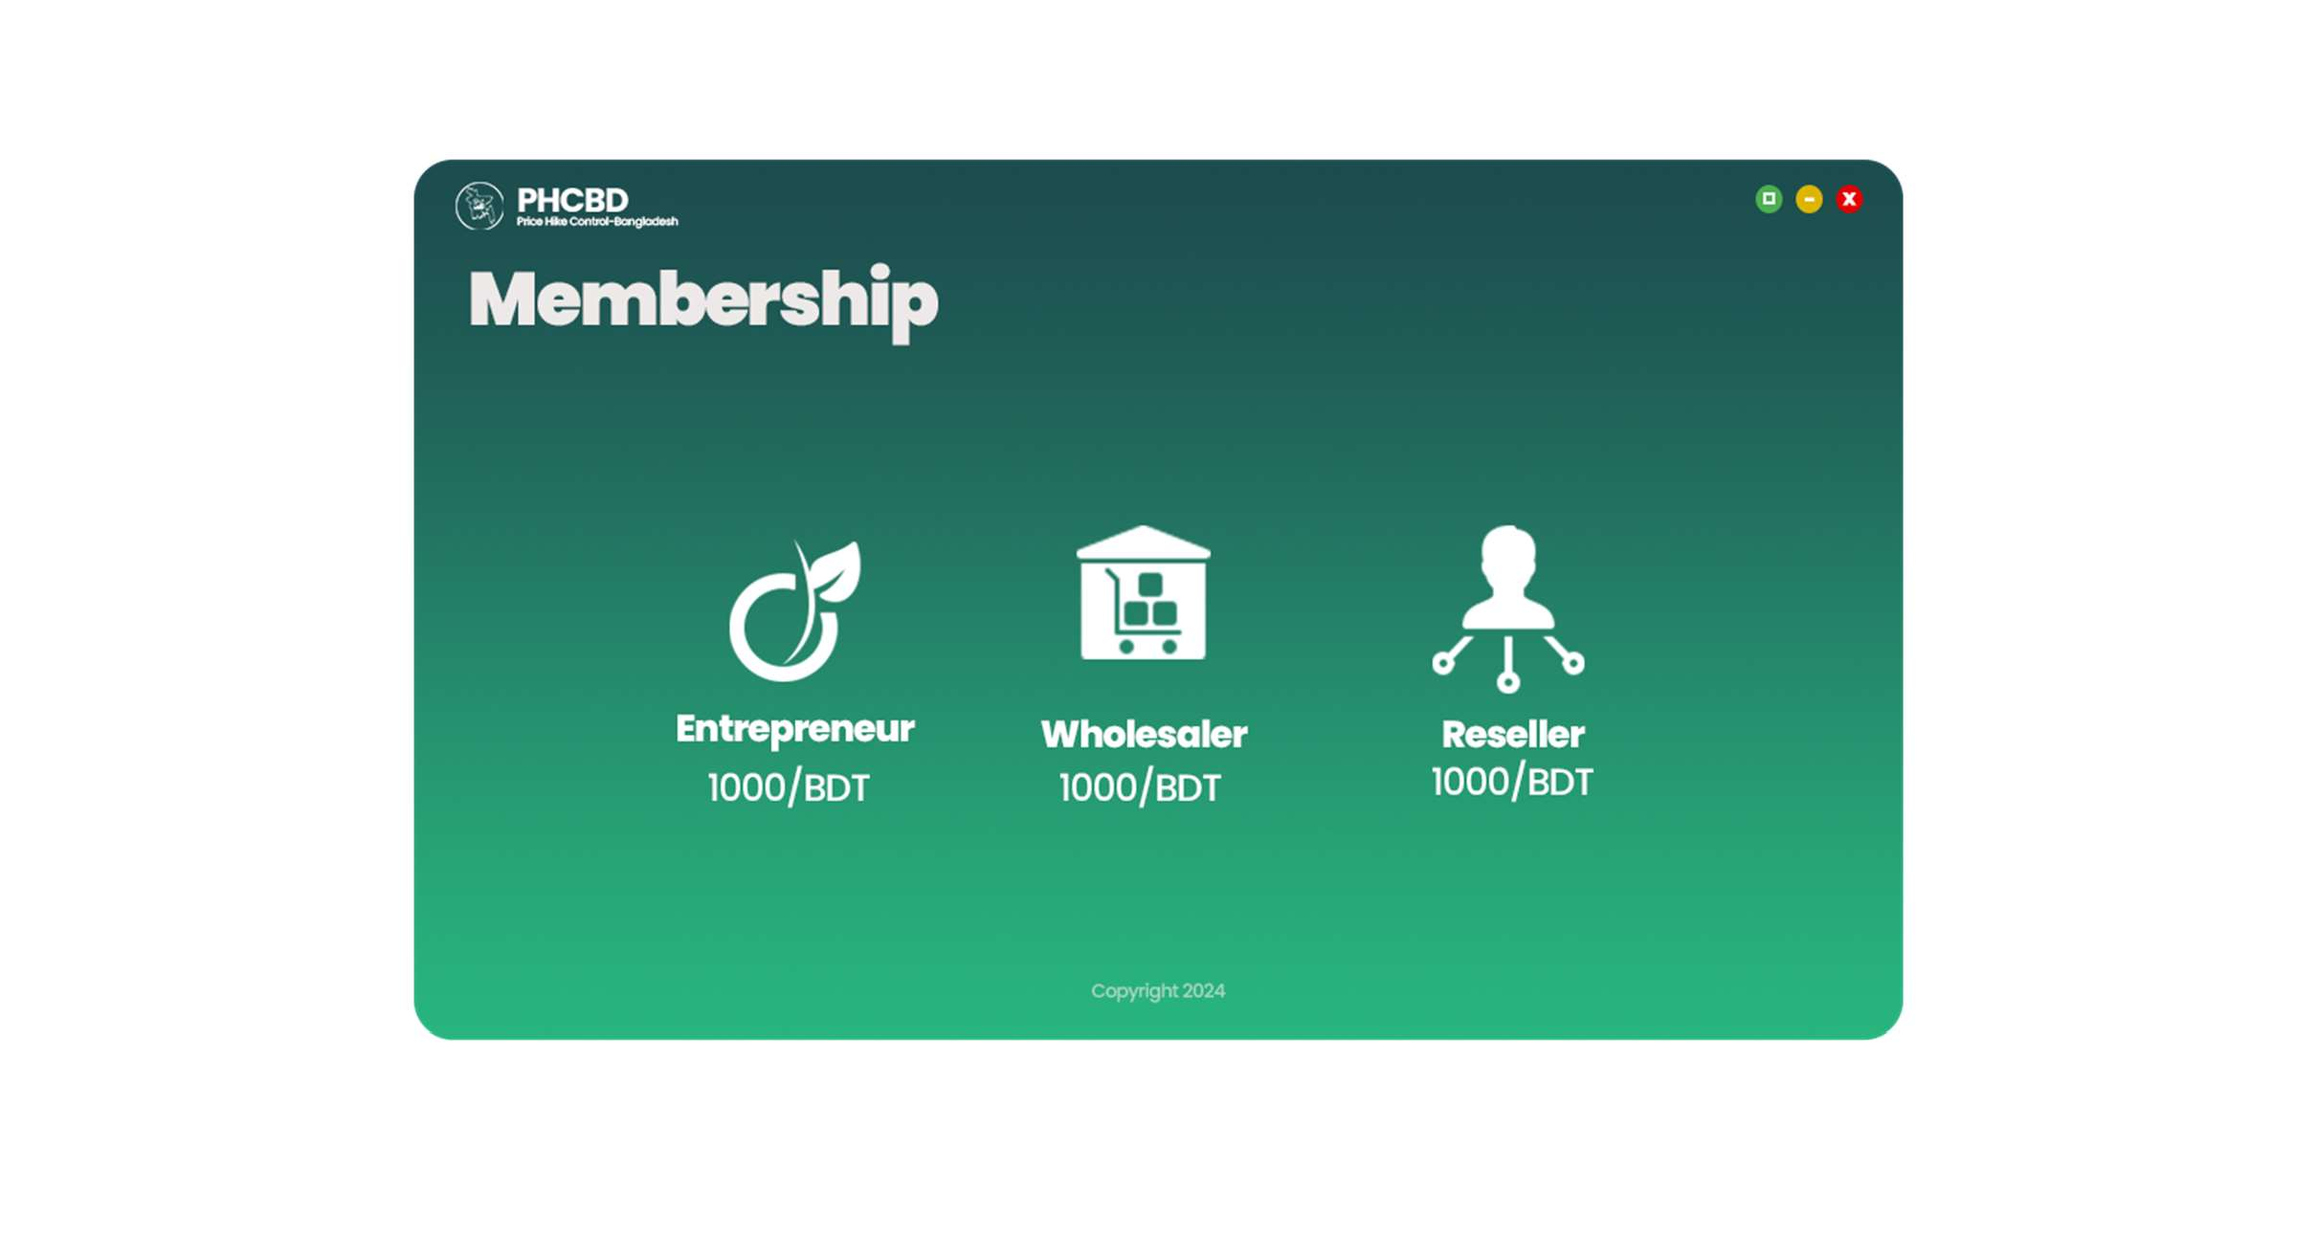

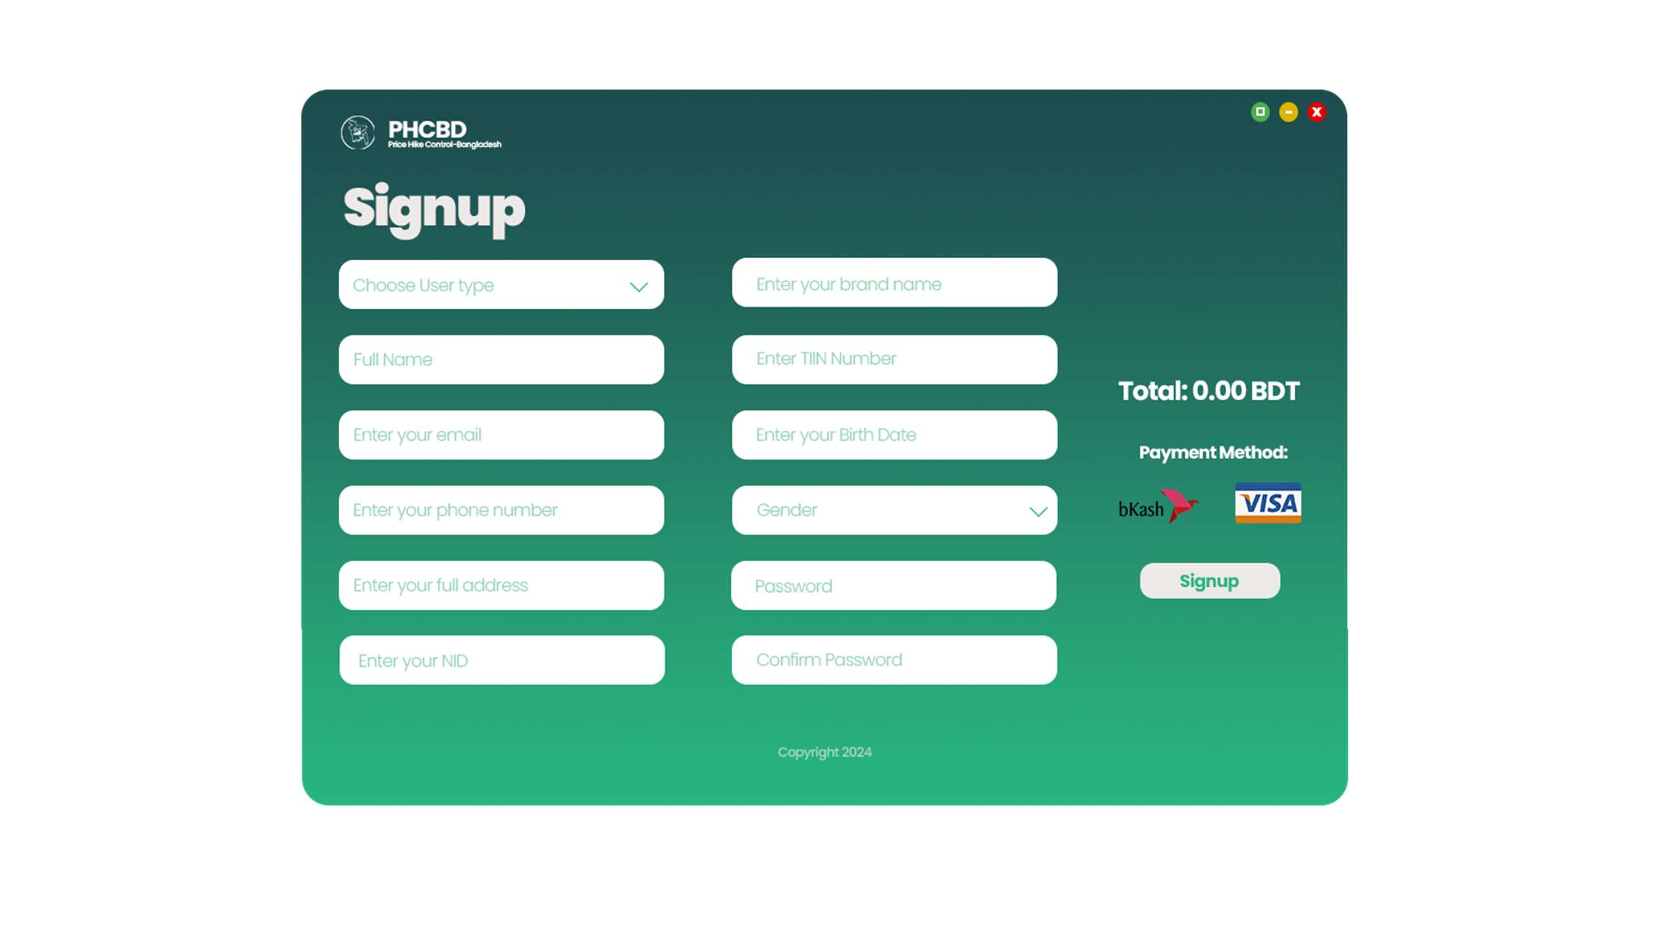

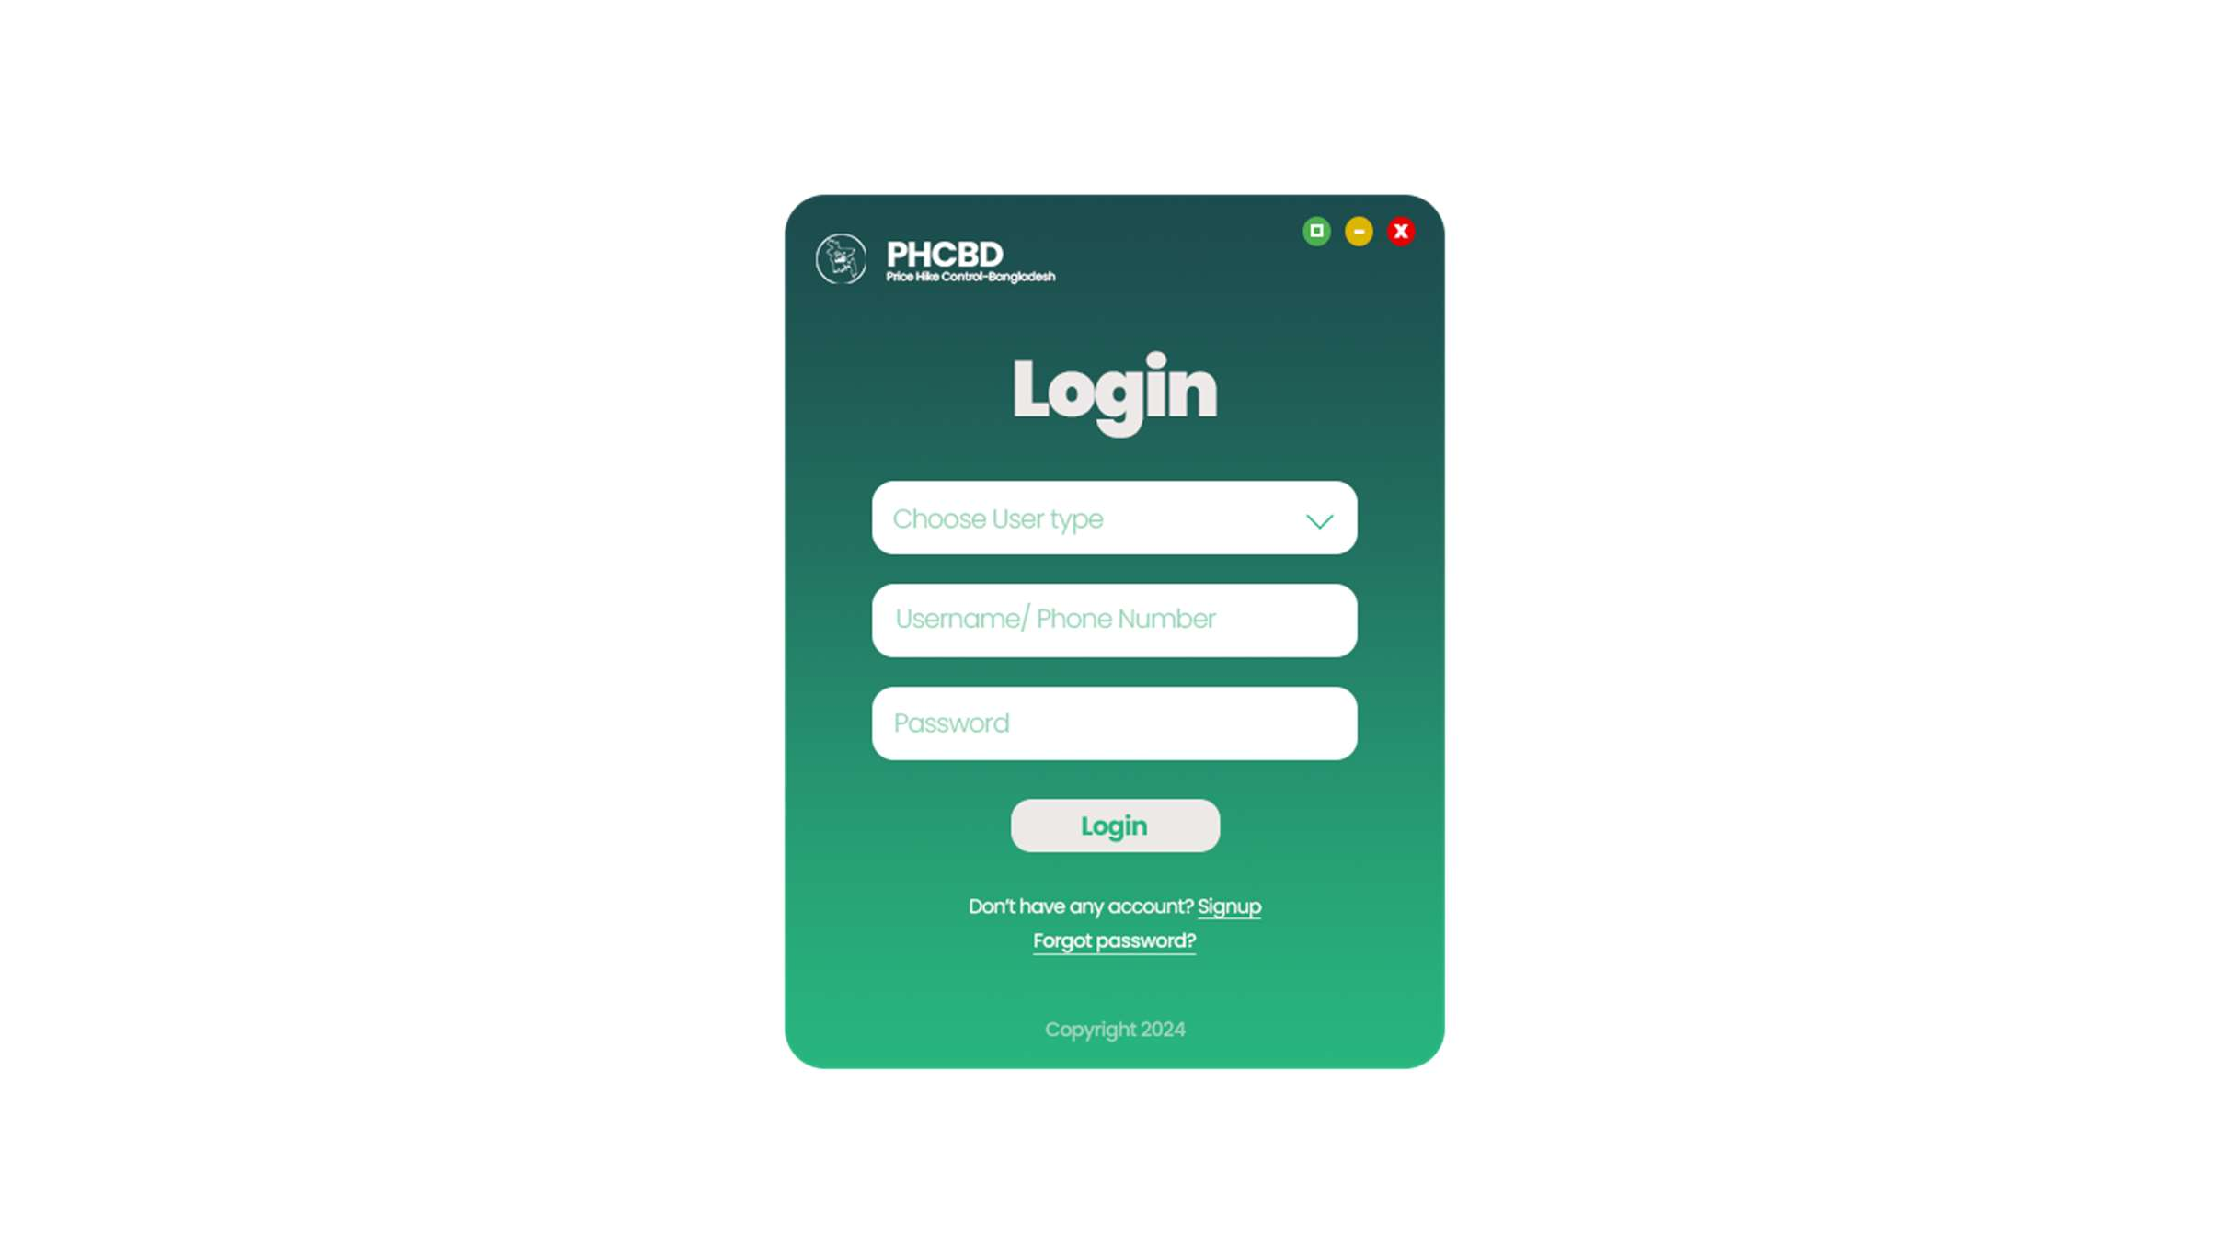

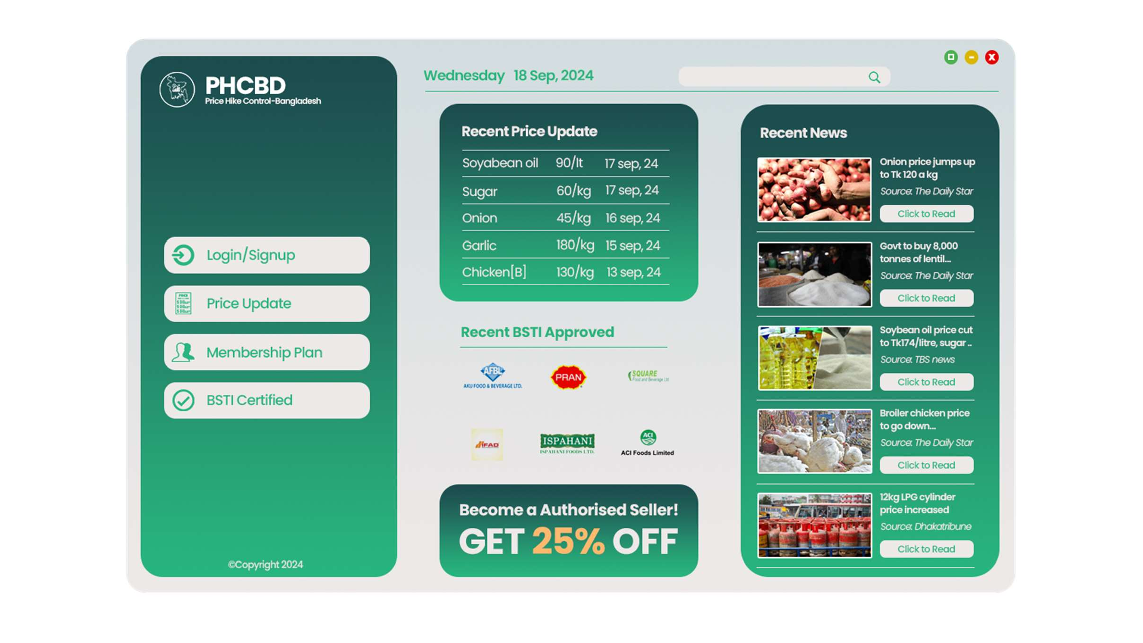

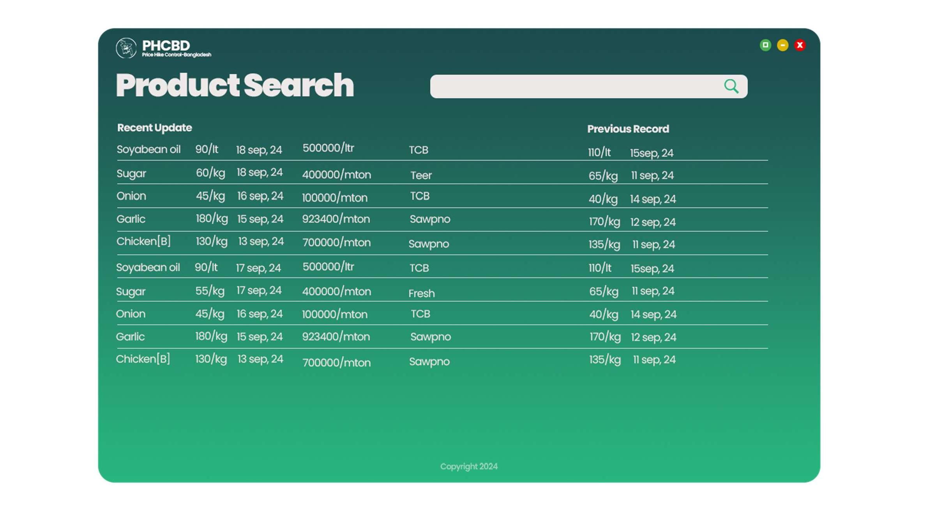

Things to concern:

* **Regular Monitoring**
* **Physical Stock monitoring**
* **Reach out to mass people or Rural area**
* **Mobile App or a Responsive app needed**

**Work Breakdown Structure**

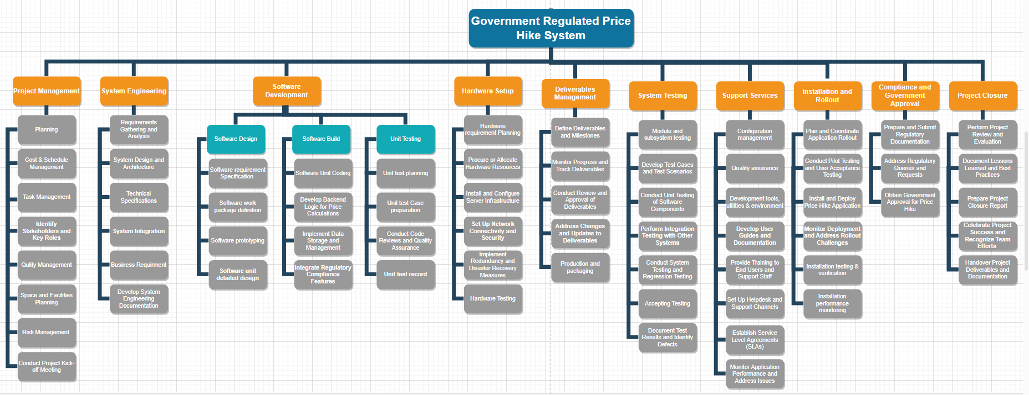





**Gantt Chart**

|  |  |  |  |  |  |  |  |  |  |  |  |  |  |  |  |  |  |  |  |  |  |  |  |  |  |  |  |  |  |  |  |
| --- | --- | --- | --- | --- | --- | --- | --- | --- | --- | --- | --- | --- | --- | --- | --- | --- | --- | --- | --- | --- | --- | --- | --- | --- | --- | --- | --- | --- | --- | --- | --- |
|  | **Pre-Game** | | | | | | | | | | | | **Game** | | | | | | | | | | | | | **Post-Game** | | | | | |
| **Task** | **Sprint** | **Initialize** | | | **Sprint 1** | | | **Sprint 2** | | | **Sprint 3** | | | **Sprint 4** | | | **Sprint 5** | | | **Sprint 6** | | | **Sprint 7** | | | **Sprint 8** | | | **Sprint 9** | | |
| **Week** | **0** | **1** | **2** | **3** | **4** | **5** | **6** | **7** | **8** | **9** | **10** | **11** | **12** | **13** | **14** | **15** | **16** | **17** | **18** | **19** | **20** | **21** | **22** | **23** | **24** | **25** | **26** | **27** | **28** | **29** |
| Planning | |  |  |  |  |  |  |  |  |  |  |  |  |  |  |  |  |  |  |  |  |  |  |  |  |  |  |  |  |  |  |
| Cost and Schedule Management | |  |  |  |  |  |  |  |  |  |  |  |  |  |  |  |  |  |  |  |  |  |  |  |  |  |  |  |  |  |  |
| Task and Quality Management | |  |  |  |  |  |  |  |  |  |  |  |  |  |  |  |  |  |  |  |  |  |  |  |  |  |  |  |  |  |  |
| Identify stakeholders and Key Roles | |  |  |  |  |  |  |  |  |  |  |  |  |  |  |  |  |  |  |  |  |  |  |  |  |  |  |  |  |  |  |
| Risk Management | |  |  |  |  |  |  |  |  |  |  |  |  |  |  |  |  |  |  |  |  |  |  |  |  |  |  |  |  |  |  |
| Space and facility planning | |  |  |  |  |  |  |  |  |  |  |  |  |  |  |  |  |  |  |  |  |  |  |  |  |  |  |  |  |  |  |
| Conduct project kickoff meeting | |  |  |  |  |  |  |  |  |  |  |  |  |  |  |  |  |  |  |  |  |  |  |  |  |  |  |  |  |  |  |
| Requirement Gathering | |  |  |  |  |  |  |  |  |  |  |  |  |  |  |  |  |  |  |  |  |  |  |  |  |  |  |  |  |  |  |
| Technical specification | |  |  |  |  |  |  |  |  |  |  |  |  |  |  |  |  |  |  |  |  |  |  |  |  |  |  |  |  |  |  |
| Software Requirement Specification | |  |  |  |  |  |  |  |  |  |  |  |  |  |  |  |  |  |  |  |  |  |  |  |  |  |  |  |  |  |  |
| Software Unit Coding | |  |  |  |  |  |  |  |  |  |  |  |  |  |  |  |  |  |  |  |  |  |  |  |  |  |  |  |  |  |  |
| Unit test planning | |  |  |  |  |  |  |  |  |  |  |  |  |  |  |  |  |  |  |  |  |  |  |  |  |  |  |  |  |  |  |
| Software Work Package Definition | |  |  |  |  |  |  |  |  |  |  |  |  |  |  |  |  |  |  |  |  |  |  |  |  |  |  |  |  |  |  |
| Develop Backend Logic for Price calculation | |  |  |  |  |  |  |  |  |  |  |  |  |  |  |  |  |  |  |  |  |  |  |  |  |  |  |  |  |  |  |
| Unit test case preparation | |  |  |  |  |  |  |  |  |  |  |  |  |  |  |  |  |  |  |  |  |  |  |  |  |  |  |  |  |  |  |
| Software Prototyping | |  |  |  |  |  |  |  |  |  |  |  |  |  |  |  |  |  |  |  |  |  |  |  |  |  |  |  |  |  |  |
| Implement Data Storage and management | |  |  |  |  |  |  |  |  |  |  |  |  |  |  |  |  |  |  |  |  |  |  |  |  |  |  |  |  |  |  |
| Conduct Code Reviews and assurance | |  |  |  |  |  |  |  |  |  |  |  |  |  |  |  |  |  |  |  |  |  |  |  |  |  |  |  |  |  |  |
| Software Unit detailed Design | |  |  |  |  |  |  |  |  |  |  |  |  |  |  |  |  |  |  |  |  |  |  |  |  |  |  |  |  |  |  |
| Integrate Regulatory Compliance Facilities | |  |  |  |  |  |  |  |  |  |  |  |  |  |  |  |  |  |  |  |  |  |  |  |  |  |  |  |  |  |  |
| Unit Test Records | |  |  |  |  |  |  |  |  |  |  |  |  |  |  |  |  |  |  |  |  |  |  |  |  |  |  |  |  |  |  |
| Hardware Requirement Planning, Allocate | |  |  |  |  |  |  |  |  |  |  |  |  |  |  |  |  |  |  |  |  |  |  |  |  |  |  |  |  |  |  |
| Install and Configure Server | |  |  |  |  |  |  |  |  |  |  |  |  |  |  |  |  |  |  |  |  |  |  |  |  |  |  |  |  |  |  |
| Set up Connectivity and Security | |  |  |  |  |  |  |  |  |  |  |  |  |  |  |  |  |  |  |  |  |  |  |  |  |  |  |  |  |  |  |
| Disaster Recovery measures | |  |  |  |  |  |  |  |  |  |  |  |  |  |  |  |  |  |  |  |  |  |  |  |  |  |  |  |  |  |  |
| Hardware testing | |  |  |  |  |  |  |  |  |  |  |  |  |  |  |  |  |  |  |  |  |  |  |  |  |  |  |  |  |  |  |
| Module and sub system testing | |  |  |  |  |  |  |  |  |  |  |  |  |  |  |  |  |  |  |  |  |  |  |  |  |  |  |  |  |  |  |
| Develop test cases and Test scenarios | |  |  |  |  |  |  |  |  |  |  |  |  |  |  |  |  |  |  |  |  |  |  |  |  |  |  |  |  |  |  |
| Conduct Unit Testing and Software comp. | |  |  |  |  |  |  |  |  |  |  |  |  |  |  |  |  |  |  |  |  |  |  |  |  |  |  |  |  |  |  |
| Perform Integration with other systems | |  |  |  |  |  |  |  |  |  |  |  |  |  |  |  |  |  |  |  |  |  |  |  |  |  |  |  |  |  |  |
| System Integration | |  |  |  |  |  |  |  |  |  |  |  |  |  |  |  |  |  |  |  |  |  |  |  |  |  |  |  |  |  |  |
| System Testing | |  |  |  |  |  |  |  |  |  |  |  |  |  |  |  |  |  |  |  |  |  |  |  |  |  |  |  |  |  |  |
| Business Requirements | |  |  |  |  |  |  |  |  |  |  |  |  |  |  |  |  |  |  |  |  |  |  |  |  |  |  |  |  |  |  |
| Develop System Engr. Documentation | |  |  |  |  |  |  |  |  |  |  |  |  |  |  |  |  |  |  |  |  |  |  |  |  |  |  |  |  |  |  |
| Define Deliverables and Milestones | |  |  |  |  |  |  |  |  |  |  |  |  |  |  |  |  |  |  |  |  |  |  |  |  |  |  |  |  |  |  |
| Configuration Management | |  |  |  |  |  |  |  |  |  |  |  |  |  |  |  |  |  |  |  |  |  |  |  |  |  |  |  |  |  |  |
| Monitor progress and Track Deliverables | |  |  |  |  |  |  |  |  |  |  |  |  |  |  |  |  |  |  |  |  |  |  |  |  |  |  |  |  |  |  |
| Quality Assurance | |  |  |  |  |  |  |  |  |  |  |  |  |  |  |  |  |  |  |  |  |  |  |  |  |  |  |  |  |  |  |
| Conduct Review and approval of delivery | |  |  |  |  |  |  |  |  |  |  |  |  |  |  |  |  |  |  |  |  |  |  |  |  |  |  |  |  |  |  |
| Development tools, utilities, environments | |  |  |  |  |  |  |  |  |  |  |  |  |  |  |  |  |  |  |  |  |  |  |  |  |  |  |  |  |  |  |
| Address Changes and updates to deliver | |  |  |  |  |  |  |  |  |  |  |  |  |  |  |  |  |  |  |  |  |  |  |  |  |  |  |  |  |  |  |
| Accepting Testing | |  |  |  |  |  |  |  |  |  |  |  |  |  |  |  |  |  |  |  |  |  |  |  |  |  |  |  |  |  |  |
| Document Test Results and identify defects | |  |  |  |  |  |  |  |  |  |  |  |  |  |  |  |  |  |  |  |  |  |  |  |  |  |  |  |  |  |  |
| Develop User guides and Documentation | |  |  |  |  |  |  |  |  |  |  |  |  |  |  |  |  |  |  |  |  |  |  |  |  |  |  |  |  |  |  |
| Provide training to End users, staffs | |  |  |  |  |  |  |  |  |  |  |  |  |  |  |  |  |  |  |  |  |  |  |  |  |  |  |  |  |  |  |
| Production and Packaging | |  |  |  |  |  |  |  |  |  |  |  |  |  |  |  |  |  |  |  |  |  |  |  |  |  |  |  |  |  |  |
| Setup Help desk and support channels | |  |  |  |  |  |  |  |  |  |  |  |  |  |  |  |  |  |  |  |  |  |  |  |  |  |  |  |  |  |  |
| Established service level agreement | |  |  |  |  |  |  |  |  |  |  |  |  |  |  |  |  |  |  |  |  |  |  |  |  |  |  |  |  |  |  |
| Plan and Coordinate App roll out | |  |  |  |  |  |  |  |  |  |  |  |  |  |  |  |  |  |  |  |  |  |  |  |  |  |  |  |  |  |  |
| Conduct Pilot testing | |  |  |  |  |  |  |  |  |  |  |  |  |  |  |  |  |  |  |  |  |  |  |  |  |  |  |  |  |  |  |
| Conduct User acceptance Testing | |  |  |  |  |  |  |  |  |  |  |  |  |  |  |  |  |  |  |  |  |  |  |  |  |  |  |  |  |  |  |
| Install and Deploy the Application | |  |  |  |  |  |  |  |  |  |  |  |  |  |  |  |  |  |  |  |  |  |  |  |  |  |  |  |  |  |  |
| Monitor deployment challenges | |  |  |  |  |  |  |  |  |  |  |  |  |  |  |  |  |  |  |  |  |  |  |  |  |  |  |  |  |  |  |
| Installation Testing and Verification | |  |  |  |  |  |  |  |  |  |  |  |  |  |  |  |  |  |  |  |  |  |  |  |  |  |  |  |  |  |  |
| Installation Performance monitoring | |  |  |  |  |  |  |  |  |  |  |  |  |  |  |  |  |  |  |  |  |  |  |  |  |  |  |  |  |  |  |
| Prepare and submit Documentation | |  |  |  |  |  |  |  |  |  |  |  |  |  |  |  |  |  |  |  |  |  |  |  |  |  |  |  |  |  |  |
| Address Regulatory quarries and requests | |  |  |  |  |  |  |  |  |  |  |  |  |  |  |  |  |  |  |  |  |  |  |  |  |  |  |  |  |  |  |
| Obtain Government Approval | |  |  |  |  |  |  |  |  |  |  |  |  |  |  |  |  |  |  |  |  |  |  |  |  |  |  |  |  |  |  |
| Project Review and Evaluation | |  |  |  |  |  |  |  |  |  |  |  |  |  |  |  |  |  |  |  |  |  |  |  |  |  |  |  |  |  |  |
| Document lesson learns, best practices | |  |  |  |  |  |  |  |  |  |  |  |  |  |  |  |  |  |  |  |  |  |  |  |  |  |  |  |  |  |  |
| Prepare project Closure report | |  |  |  |  |  |  |  |  |  |  |  |  |  |  |  |  |  |  |  |  |  |  |  |  |  |  |  |  |  |  |
| Celebrate project success and team efforts | |  |  |  |  |  |  |  |  |  |  |  |  |  |  |  |  |  |  |  |  |  |  |  |  |  |  |  |  |  |  |
| Handover Project deliverable and documentation | |  |  |  |  |  |  |  |  |  |  |  |  |  |  |  |  |  |  |  |  |  |  |  |  |  |  |  |  |  |  |



**BUILDING RISK TABLE:**

|  |  |  |  |  |
| --- | --- | --- | --- | --- |
| **Risk Description** | **Impact** | **Probability** | **Category** | **RMMM** |
| Regulatory Compliance Issues | 2 | 70% | PR | Mitigation: Regularly consult with legal and compliance experts. Monitoring: Conduct compliance audits at each project phase. Management: Adjust policies and procedures based on legal advice and regulatory updates. |
| System Downtime | 2 | 60% | DE, TE | Mitigation: Implement redundancy and failover systems. Monitoring: Continuously monitor system performance. Management: Develop and execute a quick recovery plan to minimize downtime. |
| User Resistance/Training | 3 | 80% | CU | Mitigation: Provide comprehensive user training early and often. Monitoring: Gather and act on user feedback regularly. Management: Adjust training methods and include usability enhancements based on user input. |
| Data Loss | 2 | 50% | TE | Mitigation: Implement automated backups and disaster recovery plans. Monitoring: Regularly test data recovery systems. Management: Develop rapid response plans to minimize loss if data loss occurs. |
| Inadequate Scalability | 2 | 60% | DE, TE | Mitigation: Design systems for scalability from the start. Monitoring: Track system performance metrics regularly. Management: Plan for scaling up infrastructure and services based on demand growth. |
| Data Breach/Security Compromise | 1 | 40% | PR, DE | Mitigation: Implement robust encryption and access controls. Monitoring: Perform regular security audits and penetration tests. Management: Have an incident response plan in place in case of breach. |
| Unforeseen Technological Changes | 3 | 50% | TE | Mitigation: Implement robust encryption and access controls. Monitoring: Perform regular security audits and penetration tests. Management: Have an incident response plan in place in case of breach. |



|  |  |  |  |  |
| --- | --- | --- | --- | --- |
| Changing Customer Needs | 2 | 50% | CU | Mitigation: Use agile development methods to accommodate changing requirements. Monitoring: Regular feedback loops with customers to ensure alignment. Management: Prioritize and adjust the scope based on evolving customer needs. |
| Vendor/Supplier Reliability | 3 | 70% | PR, TE, ST | Mitigation: Maintain strong communication with suppliers and have backup vendors. Monitoring: Regular vendor performance reviews. Management: Develop contingency plans for supplier failures or delays. |
| Skill Shortages | 2 | 60% | ST | Mitigation: Upskill current employees and have a clear hiring strategy. Monitoring: Track team skills and project needs. Management: Allocate resources for training and recruitment of required expertise. |
| Budget Overruns | 2 | 80% | BU | Mitigation: Set realistic budgets and build in contingencies. Monitoring: Regular budget reviews and expense tracking. Management: Reprioritize project tasks or secure additional funding if necessary. |

Impact values:

1. - Catastrophic
2. - Critical
3. - Marginal
4. – Negligible

**Allocation:**

**Project Management:**

**Project Manager:** Oversees the entire project, ensuring proper planning, coordination, stakeholder communication, and risk management strategies are applied.

**Legal Compliance Officer:** Ensures that the project complies with regulatory requirements and that legal concerns are addressed throughout the project lifecycle.

**Development Team:**

**System Architect:** Designs the scalable system architecture to ensure it can handle anticipated load and accommodate future growth.

**Backend Developer:** Develops the backend systems, including database interactions and API integrations.

**Frontend Developer:** Implements user interfaces for the web and mobile platforms, ensuring they are user-friendly and intuitive.

**Database Administrator:** Manages the system's database, ensuring data integrity, security, and scalability.

**Mobile App Developer:** Develops the mobile application for end-users to access system functionalities.

**Security Specialist:** Implements robust security measures to mitigate risks such as data breaches and insider threats, ensuring compliance with best practices and regulations.

**Integration Specialist:** Manages the technical integration between various system components to ensure compatibility and smooth functioning.

**Testing and Quality Assurance:**

**QA Lead:** Manages all quality assurance activities, ensuring the system meets functional, security, and scalability requirements.

**Test Analyst:** Develops and executes test plans for functional, security, and integration testing.

**QA Engineers:** Assist in functional, security, performance, and penetration testing, ensuring thorough coverage of potential vulnerabilities.

**Deployment and Maintenance:**

**Deployment Manager:** Oversees the deployment process, ensuring that scalability and downtime risks are mitigated, and coordinates with system administrators.

**System Administrators:** Manage the infrastructure, ensuring uptime, security, and system performance. They monitor for hardware failures and execute timely replacements.

**Deployment Engineers:** Assist in rolling out updates and patches to the system while ensuring minimal downtime and maintaining data integrity.

**Customer Support and Training:**

**Training Specialist:** Provides training resources and guides to ensure that both end-users and internal teams are properly trained, mitigating risks of user resistance.

**Support Engineers:** Provide technical support, address user feedback, and resolve system issues. They also ensure that customer needs and requirements are met and help maintain high user satisfaction.

**Security and Compliance:**

**Compliance Officer:** Ensures that all legal and regulatory requirements are adhered to, conducts regular audits, and coordinates with development teams for compliance adjustments.

**Incident Response Team:** Dedicated team for addressing security breaches and data loss, responsible for mitigating any immediate damage and communicating with stakeholders.

This structure emphasizes proper risk handling for scalability, security, compliance, and user support.